Hyderabad consists of numerous network towers of various network providers. The metadata consisting of the location of the towers is given to you in an array format towers, where towers[i] = [xi, yi, qi] denotes the ith network tower with location (xi, yi) and quality factor qi. All the coordinates are **integral coordinates** on the X-Y plane, and the distance between the two coordinates is the **Euclidean distance**.

You are also given an integer radius where a tower is **reachable** if the distance is **less than or equal to** radius. Outside that distance, the signal becomes garbled, and the tower is **not reachable**.

The signal quality of the ith tower at a coordinate (x, y) is calculated with the formula ⌊qi / (1 + d)⌋, where d is the distance between the tower and the coordinate. The **network quality** at a coordinate is the sum of the signal qualities from all the **reachable** towers.

Return *the array* [cx, cy] *representing the* ***integral*** *coordinate* (cx, cy) *where the* ***network quality*** *is maximum. If there are multiple coordinates with the same* ***network quality****, return the lexicographically minimum* ***non-negative*** *coordinate.*

**Note:**

* A coordinate (x1, y1) is lexicographically smaller than (x2, y2) if either:
  + x1 < x2, or
  + x1 == x2 and y1 < y2.
* ⌊val⌋ is the greatest integer less than or equal to val (the floor function).

**Example:**

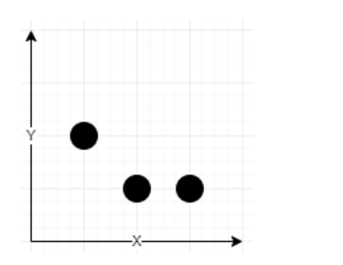

**Input:** towers = [[1,2,5],[2,1,7],[3,1,9]], radius = 2

**Output:** [2,1]

**Explanation:** At coordinate (2, 1) the total quality is 13.

- Quality of 7 from (2, 1) results in ⌊7 / (1 + sqrt(0)⌋ = ⌊7⌋ = 7

- Quality of 5 from (1, 2) results in ⌊5 / (1 + sqrt(2)⌋ = ⌊2.07⌋ = 2

- Quality of 9 from (3, 1) results in ⌊9 / (1 + sqrt(1)⌋ = ⌊4.5⌋ = 4

No other coordinate has a higher network quality.

**Constraints:**

* 1 <= towers.length <= 50
* towers[i].length == 3
* 0 <= xi, yi, qi <= 50
* 1 <= radius <= 50

**Solve the questions in C/C++/ Go lang only No other Language**